

# Student Leadership in CTE Programs

Student leadership development takes place in Career and Technical Education (CTE) programs in a variety of forms. When you embed real-world opportunities for students to direct their learning, make decisions, take risks and evaluate results—you are helping them develop into leaders!

**STUDENT LEADERSHIP SKILL DEVELOPMENT**

When we embed instruction and activities to develop student leadership, the focus is not on the technical aspects of a given CTE program (e.g. agriculture, health services, FACS, construction, business) nor on “project-based learning” but on youth development for the type of employability skills that so many employers are craving in new employees. These skills are depicted on the center of the Minnesota Career Wheel and include:

* Teamwork
* Creativity
* Innovation
* Problem solving
* Critical thinking
* Communication skills

**TRAITS OF LEADERSHIP ACTIVITIES**

Activities that develop student leadership capabilities have the following attributes:

* Student-centered
* Student planned, organized, and implemented
* Teacher as resource or advisor
* Reaches/connects beyond the classroom
* Activity-based opportunities with defined leadership development outcomes

**EXAMPLES OF LEADERSHIP ACTIVITIES**

Student leadership development opportunities should be activity-based and aligned to state frameworks and national standards. A wide range of student-led activities can be incorporated into any CTE curriculum program:

* Technical skill competitions (i.e. DECA, FCCLA, FFA, SkillsUSA, HOSA, BPA, ProStart)
* Presentations to school and civic organizations
* Experiential learning opportunities
* Partnerships with community groups
* Community service projects (including partnering with civic organizations)
* Public service announcements
* School store operation (personnel, financial, and product/distribution management)
* Coordinate development/delivery of marketing messages for school and/or community organizations

**PERKINS PROGRAM APPROVAL INCLUDES STUDENT LEADERSHIP REQUIREMENTS**

The Perkins Program Approval process developed by the Minnesota Department of Education (MDE) includes reporting on how student leadership development is embedded in your CTE program. This requirement for Program Approval, and subsequent access to requesting Perkins federal funds, is reported on the MDE Program Approval form, shown below:

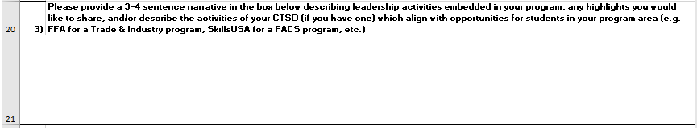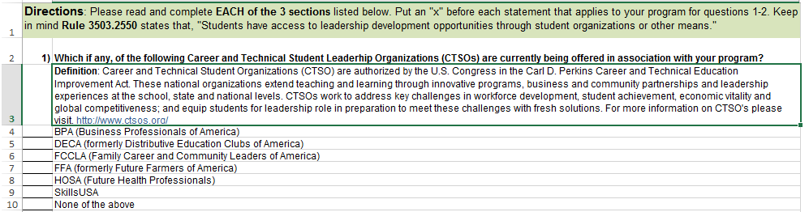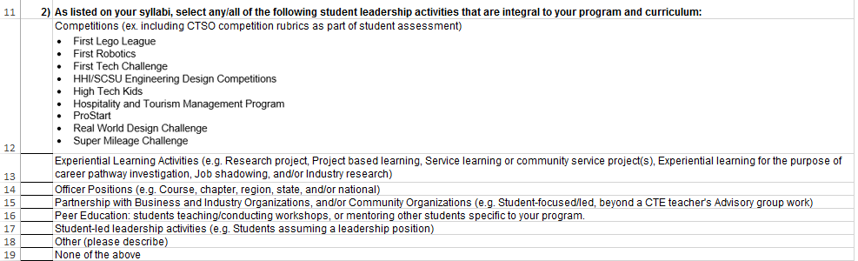

**REFLECT ON YOUR PROGRAM!**

What does student leadership development in your program look like now? As part of continuous program improvement, what changes could you envision for the next 2-3 years?